CHEMICAL ENGINEERING TRANSACTIONS  VOL., 2023 | A publication of
The Italian Association
of Chemical Engineering
Online at www.cetjournal.it
Guest Editors: Sabrina Copelli, Richard Siwek
Copyright © 2023, AIDIC Servizi S.r.l.
ISBN ; ISSN 2283-9216

Using Light Extinction as the Measure to Calculate Suspended Explosive Dust Concentration
Kingsly Ambrose*, Yumeng Zhao, Mike Sserunjogi
Department of Agricultural and Biological Engineering, Purdue University, West Lafayette, IN, USA 47907.
rambrose@purdue.edu
Dust explosion is a serious safety hazard in particulate material handling and processing industry. Within the industry, dust emission varies depending on the location of type of machinery used to handle bulk material. Monitoring of suspended dust requires installation of particle counters or other expensive measurement systems. This study explains a method of measuring dust concentration using the property of light extinction coefficient. The method analyzed the light extinction coefficient of images/videos of the suspended dust cloud between two specific targets. Using this method, calibrations were developed for grain dust, cornstarch, and sawdust. The light extinction coefficient (ε) correlated with the suspended dust concentration. Validation of the results using a single target method and the mean absolute percentage error from validations show that the proposed model is accurate and dependable in predicting suspended dust concentrations. The results indicate that this method of using light extinction coefficient to measure suspended dust concentration can be used for real-time monitoring of suspended dust concentration.
  - Introduction
Dust explosions are a hazard in the particulate material handling and processing industries and are considered the most severe hazard. Dust explosions have been reported for more than 100 years in grain handling & processing industries, sugar factories, and other processing facilities. Dust explodes when there is dispersed dust and an ignition source within a confined space. Within these factors, presence of dispersed dust in air increases the severity of explosions. Many studies have published the minimum explosive concentration (MEC) of particulate materials that could lead to an explosion. However, continuous monitoring and measuring the suspended dust concentration continues to be a challenge (Laurent, 2011).

Within industry premises, a method which could cover large measurement volume is required to monitor the MEC. Gravimetric methods are commonly used for measuring airborne dust concentration in environmental science and occupational safety-related dust concerns (Zhao and Ambrose, 2019). However, these methods are highly applicable for inhalable dust with small concentrations and are ineffective in measuring explosible limits. Hauert et al. (1996) proposed a method using Lambert-Beer law, but, this method requires calibration of the system before each measurement that is highly inconvenient. Zhong and Li (1988), Dacunto et al. (2015) proposed different methods based on light scattering principles. However, the optical beam used in these studies could become a potential ignition source (Proust, 2002).

A major challenge with suspended dust concentration measurement is that the dust clouds are not static and move with the air flow and depends on the other factors prevalent inside the confined space. Many published studies have correlated light extinction with visibility (Wang et al., 2008; Baddock et al., 2014; Camino et al., 2015). However, with varying chemical and physical properties, better correlations are needed to relate the suspended dust cloud in an industrial environment. The objective of this study is to develop a method of measuring suspended dust concentration of agricultural dusts using light extinction properties.
    - Theoretical Background
The extinction coefficient can be calculated using atmospheric light scattering models. These models relate the change in light intensity between a target and a background, at a distance R, as influenced by the extinction coefficient (Graves and Newsam, 2011):
 | $$J_{0r}=J_{0}e^{-σ_{e}R}+J_{A}(1-e^{-σ_{e}R})$$ | (1)
where, $J_{0r}$is the observed target light intensity, $J_{0}$ is the real target light intensity, and $J_{A}$ is the ambient light intensity.

The light intensity in ambient conditions depends on the prevailing environmental conditions. Therefore, the background reference $J_{g}$ is introduced to calibrate the extinction coefficient:
 | $$σ_{e}=\frac{\ln\left(\frac{J_{0r-}J_{gr}}{J_{0}-J_{g}}\right)}{R}$$ | (2)
where, $J_{gr}$ is the observed background light intensity, $J_{g}$ is the real background light intensity.

The light intensity (J) can be obtained from a camera or imaging system. $J_{0}$ and $J_{g}$ are the intensities without particles between target and camera/imaging system. However, obtaining continuous data of $J_{0}$ and $J_{g}$ when measuring suspended dust concentration is not possible. Therefore, another target is required to calculate the real-time $σ_{e}$. Using two targets with different distances from the observed location enable calculation of the $σ_{e}$ without knowing $J_{0}$ and $J_{g}$ value.

Most imaging devices use a charge-coupled device (CCD) sensor, and there will be noise when sensing the light signal. Thus, a calibration to remove the noise is important before using the light intensity obtained from a CCD. J is linearly related to the intensity value obtained from a CCD sensor (G) (Healey and Kondepudy, 1994):
 | $$G= A(J+N_{DC}+N_{S}+N_{R})$$ | (3)
where,$A$ is the amplifier to increase the signal power from a CCD sensor, $N_{DC}$ is the dark current noise, $N_{S}$ is the zero mean Poisson shot noise, and $N_{R}$ is the readout noise.

The extinction coefficient calculated using the intensity value measured from two targets can be used to eliminate noise effects:
 | $$σ_{e}=\frac{\ln\left(\frac{G_{0r1}-G_{gr1}}{G_{0r2}-G_{gr2}}\right)}{R}$$ | (4)
where, $G_{0r1}$ and $G_{gr1}$ are the first target and its background intensity value calculated from the image by averaging the grey value of all pixels, respectively. $G_{0r2}$ and $G_{gr2}$ are the second target and its background intensity value also calculated from the image, respectively.
  - Materials and Methods
    - Suspended dust dispersion within experimental chamber
The detailed experimental procedure could be found in Zhao and Ambrose (2020). A plexiglass ³ chamber, with two targets placed inside, was used for suspended dust concentration measurement tests. Cornstarch, sawdust, and corn dust were used in the experimental measurements. Dust concentrations of 17.5, 25, 42.5, 50, and 67.5 g/m³ were inside the chamber.
    - Measurement of theoretical suspended dust concentration
The theoretical suspended dust concentration was measured using a 532-nm laser instrument (Besram Technology Inc, Wuhan, China). The laser system was calibrated by dispersing a known dust concentration in ethanol (Klippel et al., 2014). The change in intensity was recorded using the laser through a 30 and 60 g/m³ dust-ethanol suspension, and an exponential fit for the concentration and the change in intensity was obtained (Figure 1). Then, the dust cloud concentration in the chamber was calculated using this calibration curve, which is considered as the actual suspended dust concentration. All the measurements were conducted in triplicates.

Figure 1: Calibration curve for measuring dust concentration using a laser (Zhao and Ambrose, 2020). (▲and dotted line represents sawdust, ● and dashed line represents cornstarch, and ■ and solid line represents corn dust)

    - Experimental measurement of dust concentration
A mobile phone (iPhone 7, Apple Inc., USA) was placed inside the chamber (Figure 2) to capture video with 1080p resolution at 60 fps. The distances between the lens and Target 1 and between Target 1 and Target 2 were both 0.22 m, respectively (Figure 2). For image processing, images were extracted from the video using the open-access video processing software, FFmpeg. All the measurements were conducted in triplicates.
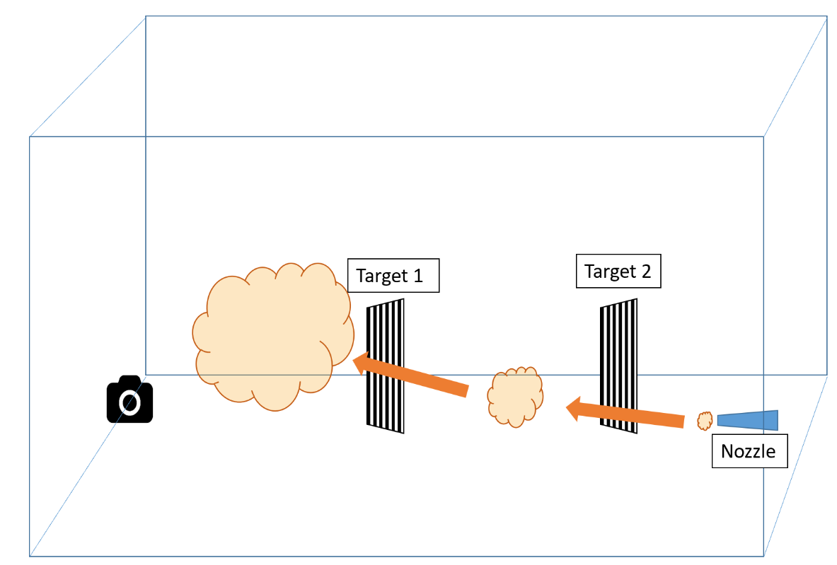
Figure 2: Schematic representation of measuring light extinction coefficient from suspended dust concentration (source: Zhao and Ambrose, 2020)

Paper printed with black and white strips was used as the targets, where the black strips are used as the target while the white strips as the reference background. Image analysis included segmenting printed targets from each photo and then separating the black and white strips in Matlab. The intensity values of each pixel from black and white strips were obtained using Matlab. The average intensity values of the black strips (B) and white background (G) were used to calculate the dust’s extinction coefficient. Please see Zhao and Ambrose (2020) for the procedure to obtain the extinction coefficient values of suspended dust. The extinction coefficient was calculated for all the individual images at intervals of 0.1 s. The suspended dust concentration changes during dispersion, so the 0.5 s interval peak extinction coefficients were averaged.
  - Results and Discussion
    - Dust concentration and extinction coefficient during dispersion
The suspended dust concentrations measured using the laser and the extinction coefficient values are plotted in Figures 3 to 5. The peak concentration of suspended dust was observed around 0.5 to 1.5 s after dispersion and then decreased with particles settling. Regardless of the concentration of dispersed dust, almost all dust settled in about 4 s.

Figure 3: Extinction coefficient of cornstarch during dispersion. (Solid line is the actual, and dashed lines are the extinction coefficient of two replicate dispersion experiments)

Figure 4: Extinction coefficient of sawdust during dispersion. (Solid line is the actual concentration, and dashed lines are the extinction coefficient of two replicate dispersion experiments)

Figure 5: Extinction coefficient of corn dust during dispersion. (Solid line is the actual concentration, and dashed lines are the extinction coefficient of two replicate dispersion experiments)

The extinction coefficient values follow a similar trend as the dust concentration during dispersion. The peak concentration was observed around 0.5–1.5 s and then declined indicating the changing suspended dust concentration affects the extinction coefficient value (Figures 3 to 5). Peak suspended dust concentration was observed when the dust is suspended uniformly throughout the chamber. The extinction coefficient shows fluctuation, which might be related to dust particle/cloud movement on the path of light between target and camera. Cornstarch tends to be more agglomerated than corn dust and sawdust and settled faster during dispersion. Thus, a steep decline after the peak value was observed during cornstarch dispersion.

The mass extinction coefficient (K) followed a linear relationship with dust concentration (Figure 6). The calculated K values for cornstarch, corn dust, and sawdust were 0.03042, 0.04158, and 0.04128 m²/g, respectively. The R² for sawdust and corn dust regression equations were 0.96, and R² for the cornstarch regression equation was 0.93. Due to particle size and particle property differences, the values reported here are much smaller than the published values for smaller particles.

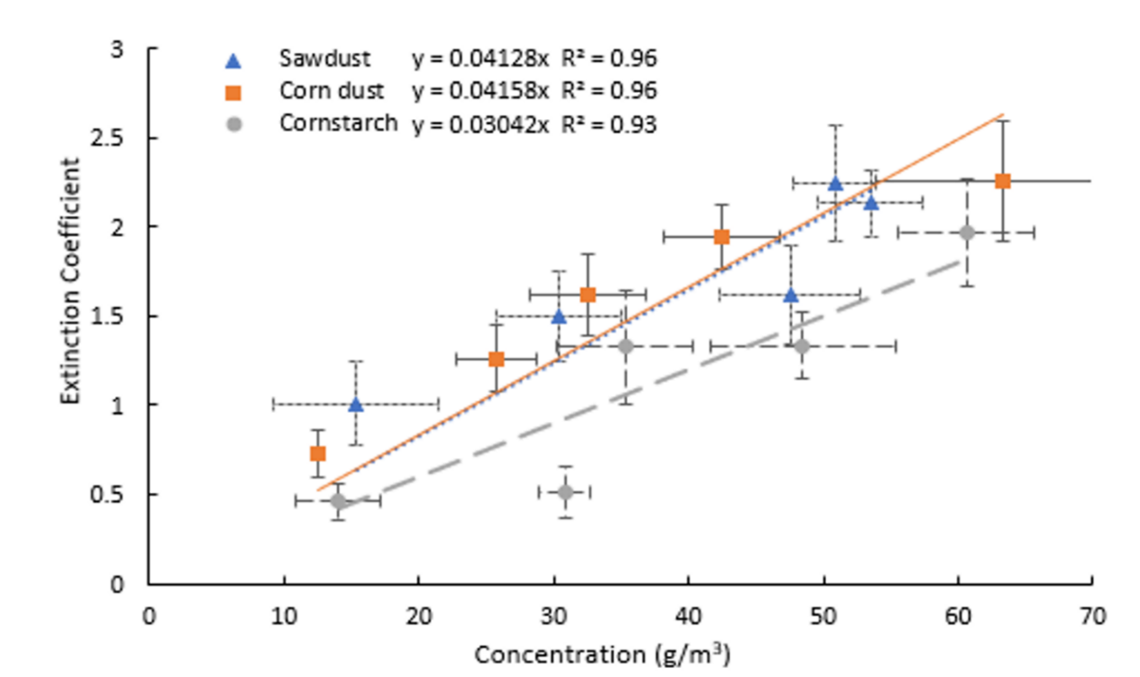
Figure 6: Extinction coefficient of dusts at different concentrations (▲and dotted line represents sawdust, ● and dashed line represents cornstarch, and ■ and solid line represents corn dust)

Further research to monitor suspended dust concentration with light extinction coefficient using the Haze image formation model and the local contrast in the spatial domain for dust image frames from a single target are being conducted for cornstarch, corn dust and saw dust. This work is being conducted at particle sizes less than 100 µm (D_{<100 µm}), and in the ranges from 100 to less than 300 (D_{100 - 300 µm}) and 300 to less than 500 (D_{300 - 500 µm}). In addition, the method is also being tested at different brightness levels of 100, 300 and 600 lumens. Results show that the change in light extinction coefficient for each dust source increases, peaks and then reduces as dust particles settle. An example of this trend with cornstarch D_{<100 µm} is shown in Figure 7. Mean absolute percentage error values less than 20% showed from corn starch D_{300 - 500 µm} showed the potential of the model to predict concentrations of suspended dust concentrations with minimal errors (Figure 8).

Figure 7: Extinction coefficient of cornstarch D_{<100 µm} suspended to achieve a concentration of 59.3 g/m³ at different brightness levels.

Figure 10: Mean Absolute Percentage Error of Corn Starch at different brightness levels
  - Conclusions
A two-target method for measuring suspended dust concentration using an imaging device was developed and tested with cornstarch, corn dust, and sawdust. This method used the light extinction coefficient of a suspended dust cloud between two targets using a digital camera. This extinction coefficient is linearly related to the suspended dust concentration. The mass extinction coefficient of suspended dust is dependent on the physical and chemical properties of the dust. Accurate measurements will therefore require a library of mass extinction coefficient values that cover a wide range of dust materials. The two-target method can be used with any imaging system thereby offering a low-cost suspended dust concentration measurement system with a rapid response time.
References
Baddock, M. C., Strong, C. L., Leys, J. F., Heidenreich, S. K., Tews, E. K., McTainsh, G. H., 2014, A visibility and total suspended dust relationship, Atmospheric Environment, 89, 329-336.
Camino, C., Cuevas, E., Basart, S., Alonso-Pérez, S., Baldasano, J. M., Terradellas, E., Berjón, A., 2015, An empirical equation to estimate mineral dust concentrations from visibility observations in Northern Africa, Aeolian Research, 16, 55-68.
Dacunto, P. J., Klepeis, N. E., Cheng, K. C., Acevedo-Bolton, V., Jiang, R. T., Repace, J. L., Hildemann, L. M., 2015, Determining PM 2.5 calibration curves for a low-cost particle monitor: common indoor residential aerosols, Environmental Science: Processes & Impacts, 17(11), 1959-1966.
Graves, N., Newsam, S., 2011, Using visibility cameras to estimate atmospheric light extinction, 2011 IEEE Workshop on Applications of Computer Vision (WACV), Kona, HI, 577–584.
Hauert, F., Vogl, A., Radandt, S.,1996, Dust cloud characterization and its influence on the pressure‐time‐history in silos, Process Safety Progress, 15(3), 178-184.
Healey, G. E., Kondepudy, R., 1994, Radiometric CCD camera calibration and noise estimation, IEEE Transactions on Pattern Analysis and Machine Intelligence, 16(3), 267-276.
Laurent, A., 2011, Sécurité des procédés chimiques. Connaissances et méthodes d’analyse des risques (2° Éd.). Lavoisier. 267.
Proust, C., 2002, Laser ignition of dust clouds, Journal de Physique IV, 12 (7), 79-88.
Wang, Y. Q., Zhang, X. Y., Gong, S. L., Zhou, C. H., Hu, X. Q., Liu, H. L., Yang, Y. Q., 2008, Surface observation of sand and dust storm in East Asia and its application in CUACE/Dust, Atmospheric Chemistry and Physics, 8(3), 545-553.
Zhao, Y., Ambrose, R. K., 2019, Modeling dust dispersion and suspension pattern under turbulence, Journal of Loss Prevention in the Process Industries, 62, 103934.
Zhao, Y., Ambrose, R. K., 2020, A real-time method of sensing suspended dust concentration from the light extinction coefficient, Journal of Loss Prevention in the Process Industries, 67, 104242.
Zhong, X. X., Li, J. S., 1988, Optical fiber sensor for dust concentration measurement, Proceedings SPIE 0838, Fiber Optic and Laser Sensors V, San Diego, CA, 285-287.

